**FOULING BUILD-UP IN INDUSTRIAL HEAT EXCHANGERS**

**Submitted by**

**Group 4**

Aliana Andres, Curtis Rhodes, Dorothy Wan, Ricky Fan for report

Department of Chemical Engineering, University of Waterloo, Waterloo, ON, N2L 3G1

Honour pledge

By electronically submitting this report I/we pledge that I/we am/are the sole contributor to the written lab report and the work contained in the report is our own group’s work. I /we fully understood the consequences of academic misconducts including plagiarism, cheating, copying, sharing etc. as stipulated in UW Policy #71.

|  |  |  |
| --- | --- | --- |
| Name | ID | Signature |
| Aliana Andres | 20833161 |  |
| Curtis Rhodes | 20832081 |  |
| Ricky Fan | 20836923 |  |
| Dorothy Wan | 20846090 |  |



# Executive Summary

The project tackles the critical challenge of fouling in industrial heat exchangers, adversely affecting thermal efficiency and chemical manufacturing processes globally. Petro Canada, facing significant financial losses and downtime due to fouling, is the primary focus. Key needs include reducing fouling build-up, applicability to various heat exchanger designs, and enhancing or maintaining efficiency. Stakeholders involve Petro Canada, chemical process companies, heat exchanger manufacturers, and cleaning companies. The project aligns with Sustainable Development Goals (SDGs) 9 and 12 by promoting innovation for sustainable industries and encouraging efficient resource consumption. The problem statement emphasizes the goal of decreasing fouling while maintaining performance efficiency. The solution must be cost improving, long-lasting, and maintaining a correction factor above 0.8. The criteria include a 10% increase in effective uptime, no negative economic or safety impacts, and a 10% increase in thermal efficiency. The decision matrix identifies two approved solutions: redesigning the steam trap and optimizing the cleaning schedule and operating conditions of the heat exchanger. The literature review covers fouling effects, cleaning methods, and the importance of optimized schedules and steam trap design. The selected solution involves redesigning the steam trap and optimizing the cleaning schedule for heat exchanger, E322. Preliminary calculations and Aspen simulations have been completed. The impact analysis involves the economic and safety impact through performing cost and HAZOP analysis. Individual contributions include steam trap sizing, Aspen simulations, data analysis, and machine learning model development. Completed tasks include Aspen simulations, initial AI model design, and finalization of project requirements. Critical milestones include validating the steam trap design through Aspen simulations and forecasting heat exchanger data trends with Facebook Prophet. In summary, the design of a 3” or 4” steam trap and optimized cleaning schedule resulted in a reduction of downtime costs of $50 million with a total of 4 cleaning sessions, each 5 days long over the course of 10 years. This project was completed by Curtis, Ricky, Aliana, and Dorothy all contributing to various technical aspects of the solution.

Table of Contents

Executive Summary ii

1. Context 6

1.1. Needs 6

1.2. Stakeholders 6

1.3. SDGs Relating to Problem Statement: 6

1.4. Background Information 7

2. Statement and Specifications 7

2.1. Problem Statement 7

2.2. Specifications 7

**2.2.1.** Constraints 7

**2.2.2.** Criteria 7

3. Literature Review 8

3.1. Effects of Fouling in Industrial Heat Exchangers 8

3.2. Fouling Cleaning Methods for Industrial Heat Exchangers 8

3.3. Optimized Cleaning Schedules for Industrial Heat Exchangers due to Fouling 8

3.4. Steam Trap Design and Effects of Poor Management 9

3.5. Steam Trap Sizing 10

4. Technical Design Analysis 11

4.1. Technical Design 11

4.2. Design Progress 12

**4.2.1.** Prediction Model 12

5. Impact Analysis 16

6. Conclusions 18

7. Individual Contributions 19

7.1. Aliana’s Contribution 19

7.2. Dorothy’s Contribution 20

7.3. Curtis’ Contribution 20

7.4. Ricky’s Contribution 21

8. Works Cited 23

Appendices 25

Appendix A.1. - Project Management Plan 25

Appendix B- Sample Calculations, Aspen 25

Appendix B.1 – Sample Calculations 25

Appendix B.2 – Aspen Plus 28

Appendix C – Python Scripts and Software 29

Appendix C.1 – Random Noise Function 29

Appendix C.2 – Cleaning Script 29

Appendix C.3 – Optimization Script 31

Appendix C.4 – Streamlit App 32

Appendix D.1 - Solution Generation 36

**Table of Tables**

Table I – Steam Trap Sizing Factors [16] 10

Table II - Solution Satisfaction Against Constraints 11

Table III – Optimized simulation parameters 14

Table IV – Baseline Cost Analysis 16

Table V – Scenario Cost Analysis 17

Table VI – HAZOP Analysis 17

Table VII - Go/No Go Test 36

Table VIII - Solution Decision Matrix 37

**Table of Figures**

Figure 1 - Optimized Cleaning Schedule from Tian et al. [9] 9

Figure 2 - Drawing of System 11

Figure 3 – Prophet prediction of performance value vs time 12

Figure 4 – Simulation of Performance vs Time 13

Figure 5 – Simulation of Heat Duty vs Time 13

Figure 6 – Optimized simulation of Performance vs Time 14

Figure 7 – Optimized simulation of Heat Duty vs Time 15

Figure 8 - Web application built in streamlit 16

Figure 9 – Steam Trap Sizing Capacity Chart [21] 19

Figure 10 - Isometric Drawing of Steam Trap Line 20

Figure 11 - Initial Aspen Model 21

Figure 12 – Data visualization within Python 22

Figure 13 - Web application built in streamlit 22

Figure 14 – Decision Map of Project 25

Figure 15 - TEMA Sheet for Simulated Heat Exchanger 28

Figure 16 - Redacted Data Sheet of Heat Exchanger E322 Provided by Petro Canada 29

Figure 17 – Information and Data Gathering Decision Diagram 38

**Table of Equations**

Equation 1 9

Equation 2 10

Equation 3 13

Equation 4 19

Equation 5 19

Equation 6 20

Equation 7 20

Equation 8 20

Equation 9 20

Equation 10 21

Equation 11 21

Equation 12 21

Equation 13 21

Equation 14 21

# Context

## Needs

One of the needs required to solve the problem is reducing the amount of fouling build up in industrial heat exchangers. This is the most important need as the problem is that fouling reduces the efficacy of the process, costing the company time and money. Another need is the solution must be applicable for a wide range of heat exchanger designs since not every industrial process will use the same type of heat exchanger and it is necessary for the solution to be well implementable in the chemical engineering industry. Another need of the solution is it must increase or maintain the efficiency of the heat exchanger prior to the build-up of fouling. The solution must not have a negative effect on the heat exchanger’s ability to heat the fluid as required by the process and ideally the solution would increase the efficiency due to the reduction of fouling.

## Stakeholders

The stakeholders for this project include Petro Canada, chemical process companies that use and rely on heat exchangers in their processes, heat exchanger manufacturers and heat exchanger cleaning companies. Petro Canada is the main stakeholder as they have identified fouling in the heat exchangers used in their processes as a large issue that has caused them large amounts of money over the years to shut down and clean. Solving the issue would reduce the financial costs of the heat exchanger and reduce the amount of time spent on the heat exchanger during scheduled shutdowns.

## SDGs Relating to Problem Statement

Two of the sustainable development goals (SDGs) relate to the problem of fouling build-up in heat exchangers reducing the heat transfer capabilities and efficiency of the process. The first goal is SDG 9 which focuses on industry and infrastructure, specifically industrial growth, and innovation towards sustainable development [1]. The target that relates the most is target 9.4 which aims to improve the innovation and technology to create sustainable infrastructure and industries. By reducing the amount of fouling on heat exchangers, the amount of energy required to use the heat exchanger is reduced which lowers the overall energy consumption and carbon footprint of the company. SDG 12 focuses on sustainable consumption of resources to improve the production patterns and encourage more sustainable practices [1]. Target 12.2 is specific towards efficient use and management of natural resources which is applicable since increasing the efficiency of the heat transfer of the heat exchanger would reduce the amount of water and energy needed to heat the process fluid. Finding the optimal cleaning schedule of the heat exchanger would also reduce the number of resources needed to clean the heat exchanger without sacrificing efficiency of the process.

## Background Information

Fouling in industrial heat exchangers occurs because of a build-up of materials from the process over an extended period. The heat transfer resistance increases which reduces the efficacy of the heat exchanger as the fouling directly impacts the heating fluid’s ability to heat the process fluid. Due to how common heat exchangers are used for industrial processes and since the process fluids in oil and gas industries are typically hydrocarbons, fouling is a large issue in refineries and is often costly for companies to fix. The undesired outlet conditions from the heat exchanger would require a higher energy consumption further downstream, which is noted in the heat duty values seen within the analysis.

# Statement and Specifications

## Problem Statement

Fouling within heat exchangers used in the oil and gas industry results in a decrease of thermal efficiency and affects chemical manufacturing processes globally. The goal of this project is to decrease the amount of fouling while maintaining performance efficiency.

## Specifications

### Constraints

The constraints of the design of the solution are that the solution must be achieve a cost improvement of about 10%, have a lifetime of 5 to 10 years, and the correction factors are maintained above 0.8. The cost improvement of the solution is based on the economic impact and the data received from Petro Canada on the typical operational and downtime costs of shutdowns. The lifetime of the solution must be within or exceed five to ten years of applicability. This is an appropriate lifetime as industrial heat exchangers typically have a lifetime of about twenty years [2] and our optimized cleaning solution is applicable for up to 10 years, based on the information from the Mississauga facility. The correction factor for the solution is calculated based on the time series data set. The values output from applying the optimized cleaning schedule are consistently above 0.8.

### Criteria

The first solution criterion is the effective uptime of heat exchangers is increased by 10% through the optimization of the cleaning schedule. This increase in uptime would result in an increase in amount of product produced and decrease the amount of time and money spent on cleaning the heat exchanger. Another criterion is that there are no negative safety or economic impacts. It is vital that the solution does not have negative implications on society or Petro Canada if they were to implement the solution. The designed solution should result in an increase in thermal efficiency of 10%. The thermal efficiency is determined by comparing the actual heat transfer occurring through the heat exchanger to the optimum heat transfer rate.

# Literature Review

## Effects of Fouling in Industrial Heat Exchangers

Fouling is one of the largest and most common issues across industries with heat exchangers. Fouling is the buildup of undesired materials on the inner surfaces of heat exchangers, often limescale. Since heat exchangers are constantly heating or cooling fluids, the materials eventually accumulate and decrease the efficiency and productivity of the heat exchanger. It affects processes in terms of energy efficiency and heat exchanger performance. According to Berce *et al.* [3], large pressure drops and an increase in friction that result from fouling render heat exchangers inoperable. Trafczynski *et al.* [4] established that reduced energy efficiency because of fouling affects the heat exchanger network existing in a plant, causing a decrease in heat and product recovery. The decrease in productivity of heat exchangers cause companies to explore options to improve their systems and to mitigate the effects of fouling while considering costs and production requirements. In some cases, fouling can lead to corrosion of the heat exchanger materials causing it to be replaced sooner than expected [5]. Fouling in crude oil refineries results in large amounts of carbon dioxide emissions [6], causing fouling to be both an industrial and environmental concern. The purpose of the capstone is to reduce the effects of fouling by implementing a steam trap on the heat exchanger outlet and designing an optimal cleaning schedule.

## Fouling Cleaning Methods for Industrial Heat Exchangers

There are various methods to clean industrial heat exchangers subject to fouling. There are on-line and off-line ways which will be looked at for this project. On-line mitigation includes many different methodologies that can be divided, in order of their applicability, into (i) changing operating conditions, (ii) chemical, (iii) mechanical, and (iv) physical approaches. Heat exchangers may be cleaned by various off-line methods including fluid cleaning, chemical and mechanical [7]. Shell and tube heat exchangers have two primary methods of cleaning: (a) hydro blasting and (b) chemical cleaning. Hydro blasting applications, involves water to be pumped to pressures ranging from 10,000 to 40,000 psi in specialized pumps. This method is effective at removing foulants from the tubes. Chemical cleaning methods can be investigated into two broader categories: (a) reactive cleaning and (b) decontamination. In both cases, chemical cleaning utilizes a combination of three main parameters: chemistry, flow, and temperature [8].

## Optimized Cleaning Schedules for Industrial Heat Exchangers due to Fouling

Optimal cleaning of heat exchangers helps improve operating conditions that are reduced due to fouling. Flow velocity is one of the main factors considered as it correlates to fouling, heat transfer, and pressure drop. Tian *et al.* [9] used an approach involving the implementation of time intervals to model the behaviour of the heat exchanger network (HEN) and fouling occurring. Each period is divided into sub-periods depending on whether they are a cleaning sub-period or processing sub-period. Ultimately, this allows an optimization of the cleaning schedule and the flow velocities across the HEN. To form the optimization model, only fouling deposition and pressure drops were considered for the tube side. The fouling rate is determined from a series of equations that lead to the calculation to determine the performance of heat exchangers in the network. When the cleaning schedule is optimized, the result is shown below for how often cleanings are done for a network of eleven heat exchangers. When the heat exchangers are cleaned too often, not only is it not economically feasible but the heat recovery is low. It is determined that optimizing the cleaning schedule without the optimization of the operating conditions results in more cleaning periods. For other cases where the optimal cleaning schedule is obtained for a HEN, heat exchangers are cleaned from one to two times per year [10], demonstrating a decrease in additional energy consumption from fouling build up on heat exchangers.

Figure 1 - Optimized Cleaning Schedule from Tian et al. [9]

Pogiatzis *et al.* [11] uses a lumped parameter model to describe deposition that occurs at a uniform rate. They use the “Ma and Epstein approach” [11] to optimize the cleaning schedule by calculating the daily average loss of energy and cleaning cost as seen in *Equation 1*. This equation can be used to quantify and demonstrate the effects of fouling on heat exchangers according to factors such as energy losses, cleaning cost, operating time, and downtime. According to Diaby *et al*. [12], when a cleaning schedule is applied where there are more cleaning activities than needed for the heat exchangers in the network, increases the rate of ageing of the heat exchangers.

|  |  |
| --- | --- |
|  | Equation 1 |

## Steam Trap Design and Effects of Poor Management

Steam traps are common instrumentation that filters out non-desirable components without losing steam from the system [13]. Installing a properly designed steam trap avoids leaking steam from the system. This would result in energy loss, causing energy and maintenance costs to increase as well as possibly emitting pollutants such as greenhouse gases into the atmosphere [14]. Steam trap failure can also result when condensate is not drained quickly enough, when this occurs, it leads to corrosion or erosion of the surrounding equipment. Issues relating to condensate can impact the rest of the system and ultimately profits. According to Risko, the occurrence of leaking steam traps increases from 7% to 12% over 14 years. Water hammer events are surges of pressure in a piping system. This can occur when the steam trap has not drained its condensate causing steam to move across the water and form waves in the pipe until the water plugs the piping and this causes the condensate to drain for many days, resulting in a loss of profit [15]. Information needed to size a steam trap includes maximum pressure and temperature, operating pressure, and maximum condensate capacity [16].

## Steam Trap Sizing

Steam trap sizing is the process of choosing a trap which has the capabilities to meet the operating conditions of pressure, temperature and condensate drainage rate for a given application. Factors that affect the accuracy of steam trap sizing are [17]: (1) the unavoidably large range in condensate load for many steam services, (2) the wide variance in operating pressure and differential pressure and (3) the uncertainty of trap capacity because of error in estimating condensate temperature. Sizing errors can offset most of the system savings provided by trapping. Steam trap sizing has been mistakenly limited by many to matching end connection size of a trap to the particular pipe size being used to drain a piece of steam heated equipment. Proper steam-trap sizing is critical to efficient and reliable steam-trap operation. Incorrect steam trap sizing can undermine the design and function of the steam trap, create installation issues, and cause condensate backup, steam loss, or both [16]. Steam-trap sizing refers to the internal discharge orifice for condensate. Determining the correct size trap requires the calculation of the maximum condensate load. Furthermore, determining the operating pressure differential and the maximum allowable pressure. Also, selecting a safety factor and sizing the type of steam trap from manufacturers’ capacity tables [17]. When a steam heats a liquid indirectly through a metallic wall such as cooking coils, storage tanks, jacketed kettles and stills, the following formula, shown in Equation 2, estimates the condensate loads when heating a petroleum product. When C is condensate load (, Q is quantity of petroleum being heated , is initial temperature of liquid being heated in degrees and is the final temperature in degrees [18]. The safety load/sizing factor can also be seen in Table I below [16].

|  |  |
| --- | --- |
|  | Equation 2 |

Table I – Steam Trap Sizing Factors [16]

|  |  |
| --- | --- |
| **Types of Steam Traps** | **Sizing Factor** |
| Inverted Bucket | 3 |
| Float and Thermostatic | 2 |
| Thermostatic | 3 |
| Thermodynamic | 3 |

This engineered approach to steam trapping has contributed to large energy saving and has helped many plants achieve or exceed their energy conservation goals [19].

Based on this literature review, we have concluded that fouling is an evident issue in the industrial sector. Due to the problems that were stated, we will further investigate the optimization of cleaning schedule for specifically a company within the oil and gas industry. It is demonstrated that while cleanings should be done frequently for heat exchangers, the optimal schedule considers heat recovery, fouling rate, and costs. There will also be an incorporation of knowing that steam traps can be used to filter out undesirable components. Steam trap application is the process of first, sizing it to meet the specific condensate drainage requirement, and second, selecting a type of steam trap. Proper selection and sizing of traps as well as considering the effects of poor management will result in minimizing steam loss, prolonging premature failure, improving thermal efficiency. Since, there is a limited study for both approaches; optimizing cleaning schedule and configuration of steam trap design, this will be our focus for this project.

# Technical Design Analysis

## Technical Design

Our selected solution has two sections, steam trap design downstream of heat exchanger E322 and an optimized cleaning/operating schedule of E322. The steam trap design involves determining values such as expected flow, temperature of steam output, and mass of steam flow. The steam trap design will help to ensure that the line will function and that impurities in the condensate line are removed before they accumulate in the line. Based on the heat transfer coefficient values and effective heat exchanger area, the optimal frequency of heat exchanger cleanings can be determined. This would result in a reduced amount of waste of energy and resources such as water.

Figure 2 - Drawing of System

Table II - Solution Satisfaction Against Constraints

|  |  |
| --- | --- |
| **Constraints** | **Solution Satisfaction** |
| * Cost Improvement   + Cost improvement for downtime costs of 10% | The cost of the downtime of the shutdowns are calculated based on the data received from Petro Canada. The determined approximate improvement of the costs is 10%. |
| * Long Lasting   + Lifetime must be within or exceed five to ten years of applicability | The optimal cleaning schedule will provide optimal shutdown dates and determine when the cost of production has been limited due to drop-offs in thermal efficiency. |
| * Correction Factor   + Maintaining a correction factor above 0.8 with the implemented solution | The correction factor for the solution is calculated based on the time series data set. The values output from applying the optimized cleaning schedule are consistently above 0.8. |

## Design Progress

### Prediction Model

Using the data analysis library Meta Prophet, forecasted data can be obtained, and can be seen in Figure 3. From this graph, several pieces of key information can be obtained. The vertical red lines indicate changepoints, points in which a parameter within the process has been changed. Any data series past the middle of 2023 is a future prediction made by Prophet, indicated by an error range shaded in blue above and below the data series. This prediction was used to determine the rate of efficiency degradation in the heat exchanger.

Figure 3 – Prophet prediction of performance value vs time

Using the prediction from Prophet as a baseline, several calculations can be made to simulate the performance measure of the heat exchanger over an extended period, specifically Equation 14.

The cleaning schedule is determined by threshold values of the heat duty and the heat exchanger performance values. If the heat duty or performance measure value exceeds a certain threshold, this indicates a cleaning. A simulation of the performance value and heat duty can be seen in Figure 4 and Figure 5.

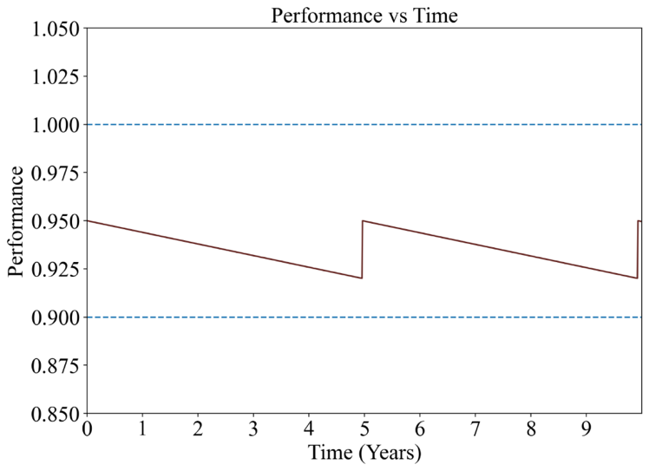

Figure 4 – Simulation of Performance vs Time

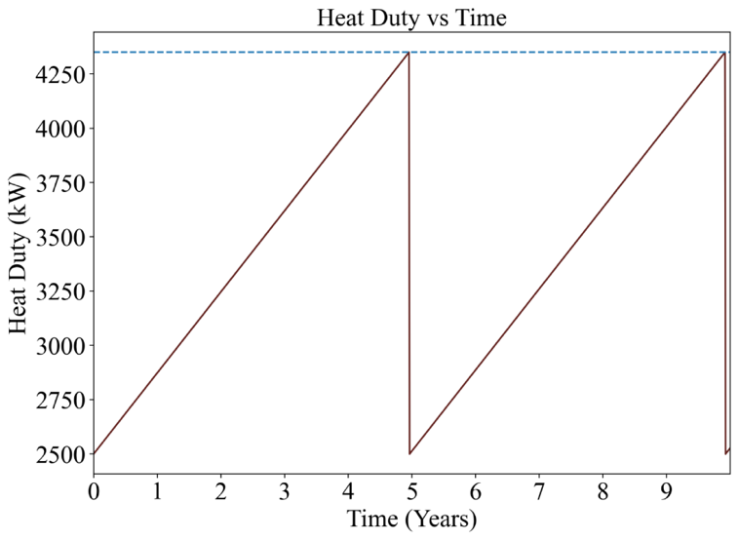

Figure 5 – Simulation of Heat Duty vs Time

Each jump in the data series indicates a cleaning of the heat exchanger, invoked by the surpassing of one of the threshold values. The script responsible for modifying the data series to include cleanings can be seen in Appendix C – Python Scripts and Software.

To determine the optimal cleaning schedule, criteria must be defined for the “most optimal”. In this case, the decision for most optimal was decided to be the lowest operating cost over a ten-year period. The operational cost function can be seen in Equation 3.

|  |  |
| --- | --- |
|  | Equation 3 |

Where is the daily energy consumption and is the cost of electricity in . The first term is the electrical operational cost of the heat exchanger, considering the daily heat duty required for heating the process fluid. The second term is the loss of product for downtime days, where the total number of downtime days is a function of the number of cleanings, multiplied by the loss of product. The final term is the maintenance cost of a single heat exchanger.

Using the *fmin* function within the library “scipy”, the costing function is minimized, with the parameters being the threshold values for the performance measure and the heat duty. Figure 6 and Figure 7 are the optimized results, and Table III contains the optimized parameters for 10 years of operation.

Table III – Optimized simulation parameters

|  |  |
| --- | --- |
| **Performance Measure Threshold** | 0.83281 |
| **Heat Duty Threshold** | 3244.92 kW |

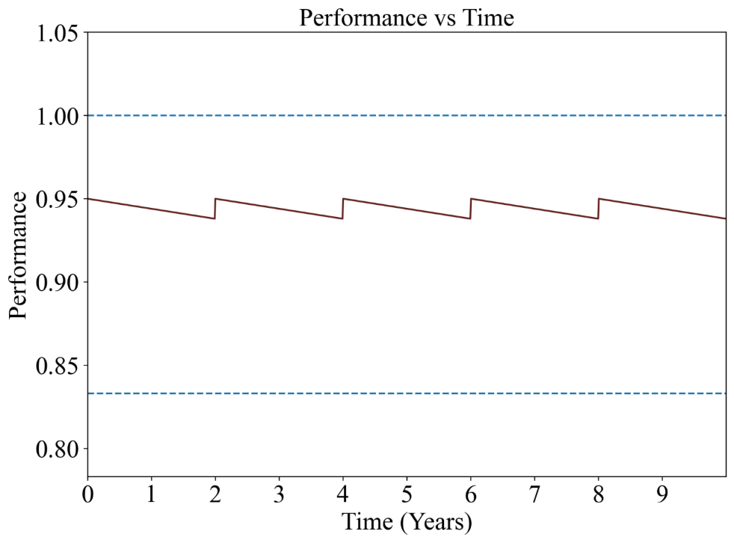

Figure 6 – Optimized simulation of Performance vs Time

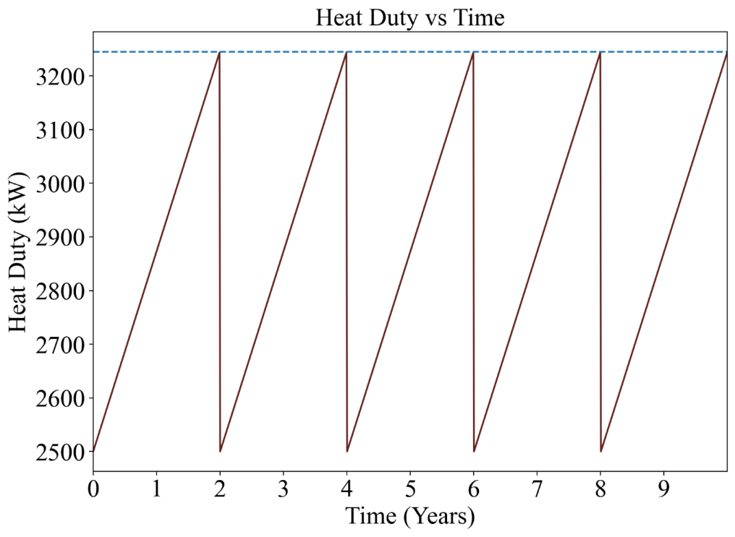

Figure 7 – Optimized simulation of Heat Duty vs Time

The software developed for the prediction model was packaged into a web application, allowing for user input to determine the simulation parameters. The web application was built using the open-source library “streamlit”, and the simulation graphs automatically populate based on the user inputs. A sample of the webapp can be seen in Figure 8.

Figure 8 - Web application built in streamlit

# Impact Analysis

The economic impact category revolves around the reduction in efficiency leading to increased energy consumption and subsequent higher energy costs. After determining using the data Petro Canada has provided [20], the solution would have a downtime of twenty (20) days of cleanings every 10 years. Based on the cost analysis performed shown in Table IV and Table V, the $6.5M reduction in downtime costs would positively affect the facility’s bottom line and improve its overall financial performance.

Table IV – Baseline Cost Analysis

|  |  |  |
| --- | --- | --- |
| **Baseline Analysis – Downtime (10 days):** |  |  |
| Electricity Costs | 18.2 | ¢/kWh |
| Operation Costs | $19,000 | per day |
| Average Daily Costs | $15,000 | per day |
| **Total Economic Impact:** |  |  |
| **Maintenance Costs** |  |  |
| Cost per Shutdown | $150,000 |  |
| Number of Shutdowns | 2 |  |
| Total Maintenance Cost | $300,000 |  |
| **Total Impact** | $56,600,000 |  |

Table V – Scenario Cost Analysis

|  |  |  |
| --- | --- | --- |
| **Scenario Analysis – Optimized Downtime (20 days):** | |  |
| Electricity Costs | 18.2 | ¢/kWh |
| Operation Costs | $14,000 | per day |
| Average Daily Costs | $12,000 | per day |
| **Total Economic Impact:** |  |  |
| **Maintenance Costs** |  |  |
| Cost per Shutdown | $150,000 |  |
| Number of Shutdowns | 4 |  |
| Total Maintenance Cost | $600,000 |  |
| **Total Impact** | $50,100,000 |  |

A HAZOP analysis has been performed to assess the safety impact of the solution. Multiple parameters were analyzed if they were to exceed expected design values. Based on the analysis, there are five nodes: before the heat exchanger, at the heat exchanger, between the heat exchanger and the steam trap, at the steam trap, after the steam trap. These nodes are areas where the control of the parameters can be placed. Common outcomes of parameter deviations include decreased heat transfer efficiency and production rate, which severely impact the efficiency of the solution. Control options for the parameters were to install control valves with electronic indicators or transducers as well as perform frequent tests on the composition of the steam to determine its moisture content.

Table VI – HAZOP Analysis

|  |  |  |  |  |
| --- | --- | --- | --- | --- |
| Parameter Deviation​ | Initiating Event(s)​ | Scenario Description​ | Outcome(s)​ | Control(s)​ |
| High Pressure Exceeds the MAWP of 300 psig​ | High pressure steam flow due to valve malfunction​ | This leads to increased fouling rate, reducing heat transfer efficiency​ | * Decreased heat transfer efficiency​ * Increased pressured drop​ * Potential equipment damage​ | Install pressure control valves with electronic pressure indicator controller​ |
| High Flow – Greater than 245,600 lbs/hour ​ | Excessive flow rate due to process demand​ | High flow rate increases the chance of fouling formation ​ | * Decreased production rate and heat transfer efficiency​ * Increased electricity costs​ | Install a flow control valve downstream of the heat exchanger​ |
| High Temperature – Greater than 340°C​ | Sudden increase in temperature ​ | This quickens the fouling rate, thus decreasing heat transfer efficiency​ | * Decreased heat exchanger and overall process efficiency​ * Increased electricity costs​ | Install temperature transducer and controllers​ |
| High composition – More than 20% water in steam | Presence of water exceeds 20% in the steam line​ | Condensate remains in the steam system and causes sudden drop of pressure ​ | * Overall steam consumption of the plant will increase * Reduces the efficiency of the operation​. * Damaging the piping and process equipment​ | Preventative maintenance – perform frequent tests​ |

# Conclusions

Fouling in industrial heat exchangers in the gas and oil industry is a common problem that costs companies worldwide millions of dollars in costs for maintenance and downtime. The solution generation process involves determining constraints and criteria for the solution. These were determined from research found during the literature review process and from speaking to the industrial advisor. The constraints are improving the cost of the downtime, ensuring the solution lasts for five to ten years, and maintaining a correction factor of at least 0.8. Based on given data from Petro Canada for values such as temperature at the inlet and outlet of the heat exchanger and the steam rating of the lines of focus, an appropriate steam trap

design and optimized cleaning schedule was determined. The steam trap design process was composed of performing calculations for condensate load and safety factor load, followed by using a data sheet for a float and thermostatic steam trap from Spirax Sarco. This ultimately determined that an appropriately sized steam trap for downstream of the heat exchanger is 3” or 4”. Preliminary calculations were done with the raw data to determine parameters such as the log mean temperature difference across the heat exchanger, the heat duty, and the correction factor. Based on information received from the external advisors, Meta Prophet was used to predict data points for correction factors for an extended period. Python was used for data visualization and to determine variable significance. The optimized cleaning schedule is determined to be four cleaning sessions of five days of cleanings over ten years, resulting in an overall cost of $50 million. This resulted in a 10% reduction compared to the baseline cost of shutdowns received from Petro Canada. Through optimization, the minimum correction factor value achieved was 0.93, satisfying one of the constraints of the solution. The magnitude of the effects of the economic and safety impacts suggests the importance of reducing fouling build up in heat exchangers in the oil industry as well as the versatility of the solution for different heat exchanger types. With an optimized cleaning schedule and augmented steam trap design, the magnitude of the impacts of fouling in heat exchangers is minimized.

# Individual Contributions

## Aliana’s Contribution

Aliana’s contributions encompassed several key aspects of steam trap sizing. Using the Yarway Industrial Steam Trapping Handbook [18] equations, particularly undertook preliminary calculations using Equation 2, which was crucial for accurate sizing. Then, utilizing the condensate load (Q) and safety load factor, the desired trap capacity was determined through the equations shown below:

|  |  |
| --- | --- |
|  | Equation 4 |
|  | Equation 5 |

Another task was to compare the different steam trap manufacturers whom which provides sizing capacity data. The potential vendor is Spirax Sarco and using its chart for FT450 as shown in Figure 9. This has been used to optimally size the steam trap for this project and this was then used to produce an isometric drawing. Lastly, Aliana performed the cost analysis for the economical impact of the solution which was done by running a baseline and a scenario analysis for the optimized schedule of 20 downtime days in 10 years. In terms of the administrative side of this project, the literature review and continuously updated the Gantt chart were Aliana’s responsibility, to keep track of our key tasks for the term.

Figure 9 – Steam Trap Sizing Capacity Chart [21]

## Dorothy’s Contribution

Dorothy’s contributions have included performing Aspen Plus simulations for the 2023 data to collect values for heat duty values, heat exchanger area, and heat transfer coefficient values. Tasks also performed are steam trap calculations to determine the sizing appropriate for the system. From the values collected from Aspen, the steam flow rate though the steam trap was calculated as part of the preliminary steam calculations. Dorothy also used AutoCAD to visualize the system and create an isometric drawing of the steam trap line. Administrative tasks of the project include keeping on top of the deadlines of deliverables and note-keeping during meetings. Another task worked on was performing research for the literature review and the safety impact analysis. This was done following HAZOP analysis format by determining different factors such as pressure and temperature to assess possible outcomes and controls that could be put in place as prevention.

|  |  |
| --- | --- |
|  | Equation 6 |

Figure 10 - Isometric Drawing of Steam Trap Line

## Curtis’ Contribution

Technical contributions associated with Curtis’s contribution include preliminary calculations associated with the initial heat exchanger data given by Petro Canada. This includes correction factor, log mean temperature difference, heat duty, heat transfer coefficients, and flowrate computations all required for initial aspen simulations. The equations utilized within this portion of the project are seen below in Equation 7-14.

|  |  |
| --- | --- |
|  | Equation 7 |
|  | Equation 8 |
|  | Equation 9 |
|  | Equation 10 |
|  | Equation 11 |
|  | Equation 12 |
|  | Equation 13 |
|  | Equation 14 |

Additionally, Curtis was responsible for the initial setup of the aspen simulation, as well as the rigorous modeling of the heat exchanger needed to obtain more accurate dimensions. The Aspen model setup design is seen below in Figure 11. The Tubular Exchanger Manufacturers Association (TEMA) sheet provided by Aspen for the rigorous design can be seen in Appendix B- Sample Calculations, Aspen, Figure 15.

Figure 11 - Initial Aspen Model

Furthermore, Curtis was responsible for simulating the 2022 data on Aspen to collect the heat duty, values, heat transfer coefficients (dirty and clean), area values, as well as the simulated correction factor values provided by Aspen. It was essential to collect these values to validate calculation results. Curtis also assisted with the implementation of costing and development of the web application code. Completion of the Time logs, Gantt chart, group and supervisor meetings were also part of the contribution.

## Ricky’s Contribution

Ricky’s technical contributions include the design of the experiment, and determining the low and high values for which the simulation within Aspen was to be run to determine variable significance. This was done using a Python script to add random noise varying between -5 to +5 % to each variable input for an inconsistent variable output, and the script used can be seen in Appendix C. Data visualization was also done within Python, and a sample graph can be seen in Figure 12.

Figure 12 – Data visualization within Python

The simulation calculations were done in Python, and the graphical user interface was developed by Ricky. The backend optimization, cleaning functions, and costing function were also developed by Ricky.

Figure 13 - Web application built in streamlit

All the developed software is available on the GitHub repo available [here](https://github.com/rickyfann/capstone). The project is entirely source controlled, with the working calculations and equations developed in all their versions, as well as related files required for running the web app backend server.

# Works Cited

|  |  |
| --- | --- |
| [1] | "The 17 Goals," United Nations, [Online]. Available: https://sdgs.un.org/goals. [Accessed 29 November 2023]. |
| [2] | CDW Engineering, "Average Life Expectancies," CDW Engineering, 2023. [Online]. Available: https://www.cdwengineering.com/average-life-expectancies/. [Accessed 29 November 2023]. |
| [3] | J. Berce, M. Zupančič, M. Može and I. Golobič, "A Review of Crystallization Fouling in Heat Exchangers," *Design Optimization and Performance Monitoring of Heat Exchangers,* vol. 9, no. 8, 2021. |
| [4] | M. Trafczynski, M. Markowski, K. Urbaniec, P. Trzcinski, S. Alabrudzinski and W. Suchecki, "Estimation of thermal effects of fouling growth for application in the scheduling of heat exchangers cleaning," *Applied Thermal Engineering,* vol. 182, pp. 1359-4311, 2021. |
| [5] | Chardon Labs, "How To Reduce Fouling In Heat Exchangers," Chardon Labs, [Online]. Available: https://www.chardonlabs.com/resources/reduce-fouling-in-heat-exchangers/#:~:text=Corrosion%20fouling%20occurs%20when%20impurities,chemically%20stable%20as%20other%20substances.. [Accessed 22 October 2023]. |
| [6] | F. Coletti and S. Macchietto, "Refinery Pre-Heat Train Network Simulation Undergoing Fouling: Assessment of Energy Efficiency and Carbon Emissions," *Heat Transfer Engineering,* vol. 32, no. 3-4, pp. 228-236, 2011. |
| [7] | M. R. W. A. P. Malayeri, "Heat Exchanger Fouling: Mitigation and Cleaning Strategies," 22 March 2011. [Online]. Available: https://doi.org/10.1080/01457632.2010.503108. |
| [8] | J. L. Davis, "Heat Exchanger Cleaning Methods," in *Energy Management and Efficiency for the Process Industries*, 2015, pp. 139-142. |
| [9] | J. Tian, Y. Wang and X. Feng, "Simultaneous optimization of flow velocity and cleaning schedule for mitigating fouling in refinery heat exchanger networks," *Energy 109,* pp. 1118-1129, 2016. |
| [10] | C. Rodriguez and R. Smith, "Optimization of Operating Conditions for Mitigating Fouling in Heat Exchanger Networks," *Chemical Engineering Research and Design,* pp. 839-851, 2007. |
| [11] | T. Pogiatzis, E. M. Ishiyama, W. R. Paterson, V. S. Vassiliadis and D. I. Wilson, "Identifying optimal cleaning cycles for heat exchangers subject to fouling and ageing.," *Applied Energy 89,* pp. 60-66, 2012. |
| [12] | A. L. Diaby, S. J. Miklavcic and J. Addai-Mensah, "Optimization of scheduled cleaning of fouled heat exchanger network under ageing using genetic algorithm," *Chemical Engineering Research and Design,* pp. 223-240, 2016. |
| [13] | Spirax Sarco, "Steam Traps and Steam Trapping," Spirax Sarco, [Online]. Available: https://www.spiraxsarco.com/learn-about-steam/steam-traps-and-steam-trapping/introduction---why-steam-traps#:~:text=The%20duty%20of%20a%20steam,all%20covered%20in%20this%20tutorial.. [Accessed 25 October 2023]. |
| [14] | J. P. Walter, "Implement a Sustainable Steam-Trap Management Program," January 2014. [Online]. Available: https://www.spiraxsarco.com/learn-about-steam/steam-traps-and-steam-trapping/introduction---why-steam-traps#:~:text=The%20duty%20of%20a%20steam,all%20covered%20in%20this%20tutorial.. [Accessed 25 October 2023]. |
| [15] | J. R. Risko, "Steam Trap Management: Do Something; Anything. Please!," October 2017. [Online]. Available: https://www.aiche.org/sites/default/files/cep/20171064.pdf. [Accessed 25 October 2023]. |
| [16] | K. Paffel, "How to properly size a steam trap: don't confuse the size of a steam-trap's end connection with the internal discharge orifice for condensate," *Chemical Engineering,* vol. 120, no. 9, p. 58+, 2013. |
| [17] | NAVAL CIVIL ENGINEERING LAB PORT HUENEME CA, "Steam Trap Users' Guide," 1 April 1985. [Online]. Available: https://apps.dtic.mil/sti/citations/ADA156315. |
| [18] | Yarway Corporation, "Industrial Steam Trapping Handbook," 1984. [Online]. Available: https://citeseerx.ist.psu.edu/document?repid=rep1&type=pdf&doi=32e977ed03f81c06c93c137803c5fa26ec12d6b5. |
| [19] | G. W. W. Richard G. Krueger, "THE ENGINEERED APPROACH TO ENERGY AND MAINTENANCE EFFECTIVE STEAM TRAPPING," 1980. [Online]. Available: https://citeseerx.ist.psu.edu/document?repid=rep1&type=pdf&doi=055d0c66eec67a91c0e4efea77d0afd2dae070f4. |
| [20] | Petro Canada Lubcricants Incorporation, "2019 Tech Talk - Fall 2018 Dewax Outage to Clean DWO Recovery Exchangers," Mississauga, 2019. |
| [21] | Spirax Sarco, "Cast Steel Float & Thermostatic Steam Trap 3” and 4” FT450," [Online]. Available: https://www.statesupply.com/media/filemanager/2/7/2756.pdf. |

# Appendices

## Appendix A.1. - Project Management Plan

Link to Gantt Chart: [Group 4 CHE482 Gantt Chart](https://uofwaterloo-my.sharepoint.com/:x:/g/personal/d8wan_uwaterloo_ca/EQZKDqVmUpJOoam88ALTglUBf3C-M0MLFgHEKAPoNsrPxA?e=xc6S0D)

Figure 14 – Decision Map of Project

## Appendix B- Sample Calculations, Aspen

Appendix B.1 – Sample Calculations

Sample calculation of Q based on steam:

Based on Aspen simulation data (taking entire duty of 6946.7 kW, Area being 230.628 m2, FT of 0.717 and a corrected LMTD of 52.75 °C – the simulation results for a sample run)

Appendix B.2 – Aspen Plus

Figure 15 - TEMA Sheet for Simulated Heat Exchanger

Figure 16 - Redacted Data Sheet of Heat Exchanger E322 Provided by Petro Canada

## Appendix C – Python Scripts and Software

Appendix C.1 – Random Noise Function

random_vals = np.random.randint(-5, 5, [1,3]) / 100

d = (datum + datum*random_vals).flatten()

d = {

"Treatment" : treatment,

"Utility Temperature" : d[0],

"Process Temperature" : d[1],

"Flowrate" : d[2]}

Appendix C.2 – Cleaning Script

import numpy as np

def main(x_vals, f_threshold, q_threshold, energy_rate):

# mathematical functions

f = lambda t,: 0.95 - (1.6522190073960615e-05 * t)

q = lambda t: 1.0228404255319148 * t + 2500

cost = lambda Q: Q * 24 * energy_rate / 100

# plotting y vals

y_vals = f(t = x_vals)

q_vals = q(t = x_vals)

check_index = []

# cleaning for resetting values

def check(y_values):

if True in list(y_values < f_threshold):

ind = list(y_values < f_threshold).index(True)

check_index.append(ind)

y_vals[ind:] = f(x_vals[:len(y_vals[ind:])])

check(y_vals)

else:

pass

check_index2 = []

def check2(q_values):

if True in list(q_values > q_threshold):

ind = list(q_values > q_threshold).index(True)

check_index2.append(ind)

q_vals[ind:] = q(x_vals[:len(y_vals[ind:])])

check2(q_vals)

else:

pass

# running function

check(y_vals)

for ind in check_index:

q_vals[ind:] = q(x_vals[:len(y_vals[ind:])])

check2(q_vals)

for ind in check_index2:

y_vals[ind:] = f(x_vals[:len(y_vals[ind:])])

return (y_vals, q_vals, max(len(check_index), len(check_index2)))

Appendix C.3 – Optimization Script

import numpy as np

from scipy.optimize import fmin

m_dot = 30.945

heat_capacity = 2.219

f = lambda t,: 0.95 - (1.6522190073960615e-05 * t)

q = lambda t: 1.0228404255319148 * t + 2500

def costing_comparison(q_array, cleanings, energy_rate):

# total operation days * cost of operation per day + downtime days * loss per downtime day

return (3650 - 5 * cleanings) * (np.average(q_array) * 24 * energy_rate / 100) + 5 * cleanings * 200000 + 900000/6 *cleanings

# return (3650 - 5 * cleanings) * cost(np.average(q_array)) + 5 * cleanings * 200000 + 900000 * cleanings

def func(par, days=3650, energy_rate=18.2):

f_threshold, q_threshold = par

x_vals = np.linspace(0, days, 1000)

y_vals = f(t = x_vals)

q_vals = q(t = x_vals)

check_index = []

# cleaning modification

def check(y_values):

if True in list(y_values < f_threshold):

ind = list(y_values < f_threshold).index(True)

check_index.append(ind)

y_vals[ind:] = f(x_vals[:len(y_vals[ind:])])

check(y_vals)

else:

pass

check_index2 = []

def check2(q_values):

if True in list(q_values > q_threshold):

ind = list(q_values > q_threshold).index(True)

check_index2.append(ind)

q_vals[ind:] = q(x_vals[:len(y_vals[ind:])])

check2(q_vals)

else:

pass

# running function

check(y_vals)

for ind in check_index:

q_vals[ind:] = q(x_vals[:len(y_vals[ind:])])

check2(q_vals)

for ind in check_index2:

y_vals[ind:] = f(x_vals[:len(y_vals[ind:])])

return costing_comparison(q_vals, max(len(check_index), len(check_index2)), energy_rate)

Appendix C.4 – Streamlit App

# ricky fan

import streamlit as st

import numpy as np

import matplotlib.pyplot as plt

from scipy.optimize import fmin

from optimization import func, costing_comparison

from pathlib import Path

import cleaning

# to run this app, open your cmd and make sure "streamlit is installed"

# then type "streamlit run {PATH TO streamlitapp.py}" into console

fonts = {

"header1": '<p style="font-family:Amasis MT Std; color:white; font-size: 44px; text-align: center;">',

"body": '<p style="font-family:Aptos Display; color:white; font-size: 25px;">',

"numbers": '<p style="font-family:Aptos Display; color:white; font-size: 30px;">',

"header2": '<p style="font-family:Aptos Display; color:white; font-size: 28px; text-align: center;">',

}

def md(font, text):

st.markdown(fonts[font] + text + "</p>", unsafe_allow_html=True)

# initialization of streamlit app and text

st.set_page_config(layout="wide")

with open(str(Path(__file__).parents[0]) + "\\styles.css") as f:

css = f.read()

st.markdown(f'<style>{css}</style>', unsafe_allow_html=True)

md("header1", "FoulX Predictor App")

md("header2", "Authors: Aliana Andres, Ricky Fan, Curtis Rhodes, Dorothy Wan")

md("body", "This is the web app tool developed by the CHE Capstone group 4. The intended use case is to determine the optimal cleaning schedule for a heat exchanger as it degrades in efficiency.")

# initial values, can be tweaked to match prophet predictions

# baseline operation days is 3650, q threshold 4350

t_initial =int(365 * 10)

f_threshold_initial = 0.9

q_threshold_initial = 4350.0 #maximum is 9157 for daily operating cost of 16759.65 over 10 years

energy_rate_initial = 18.2

with st.sidebar:

md("header2", "<strong>Parameter Inputs</strong>")

# user input parameter values

t = st.number_input("Insert parameter 1, **t**, the number of days to be modeled.", value = t_initial, min_value=1)

f_threshold = st.number_input("Insert parameter 2, **f threshold**, the correction factor.", value = f_threshold_initial, min_value=0.00, max_value=0.950)

q_threshold = st.number_input("Insert parameter 3, **q threshold**, the higher bound for the heat duty in $kW$.", value = q_threshold_initial, min_value=2600.0)

energy_rate = st.number_input("Insert parameter 4, **energy rate**, the cost of energy in $cents / kWh$.", value = energy_rate_initial, min_value=1.0, max_value=25.0)

year_enable = st.checkbox("Years/Days", value=True)

optimal = fmin(func, [0.9, 3650], (t, energy_rate))

# creation of columns to split the page

cols = st.columns(2)

# from prophet prediction, m = -1.6522190073960615e-05, m=-8.897745181041325e-06

# heat duty, m = 1.0228404255319148

# mass flowrate = 30.945 kg/s

# heat capacity = 2.219 kJ / kg C

# 18.2 cents / kWh from

# https://www.oeb.ca/consumer-information-and-protection/electricity-rates

m_dot = 30.945

heat_capacity = 2.219

# plotting x vals

x_vals = np.linspace(0, t, 1000)

y_vals, q_vals, cleanings = cleaning.main(x_vals, f_threshold, q_threshold, energy_rate)

y_vals_baseline, q_vals_baseline, cleanings_baseline = cleaning.main(x_vals, 0.9, 4350, energy_rate)

y_vals_optimized, q_vals_optimized, cleanings_optimized = cleaning.main(x_vals, optimal[0], optimal[1], energy_rate)

fig, ax1 = plt.subplots(figsize=[10,7])

# plotting values

ax1.set_title("Performance vs Time")

ax1.set_xlabel("Time (Days)")

ax1.set_ylabel("Performance")

ax1.plot(x_vals, y_vals, color="#63221E")

ax1.hlines(f_threshold, xmin = 0, xmax = t, linestyles='dashed')

ax1.hlines(1.0, xmin = 0, xmax = t, linestyles='dashed')

# plot limits

ax1.set_ylim([f_threshold-0.05, 1.05])

ax1.set_xlim([0, t])

overall_eff = np.average(y_vals)

fig2, ax2 = plt.subplots(figsize=[10,7])

ax2.set_title("Heat Duty vs Time")

ax2.set_xlabel("Time (Days)")

ax2.set_ylabel("Heat Duty (kW)")

ax2.plot(x_vals, q_vals, color="#63221E")

ax2.set_xlim([0, t])

ax2.hlines(q_threshold, xmin = 0, xmax = t, linestyles='dashed')

x_tick_locations = [int(365 * i) for i in range(t//365)]

x_tick_labels = np.arange(0, t//365)

modified = costing_comparison(q_vals, cleanings, energy_rate)

baseline = costing_comparison(q_vals_baseline, cleanings_baseline, energy_rate)

optimized = costing_comparison(q_vals_optimized, cleanings_optimized, energy_rate)

for ax in [ax1, ax2]:

for item in ([ax.title, ax.xaxis.label, ax.yaxis.label] +

ax.get_xticklabels() + ax.get_yticklabels()):

item.set_fontsize(22)

item.set_fontname("Times New Roman")

if year_enable:

for axis in (ax1, ax2):

axis.set_xlabel("Time (Years)")

axis.set_xticks(x_tick_locations)

axis.set_xticklabels(x_tick_labels)

with cols[0]:

st.pyplot(fig, use_container_width=True)

with cols[1]:

st.pyplot(fig2, use_container_width=True)

percent_diff = (baseline - modified)/baseline * 100

cols2 = st.columns([0.5, 0.5])

with cols2[0]:

md("header2", "<strong>RESULTS SUMMARY</strong>")

div = st.columns([0.5, 0.5])

with div[0]:

with st.container():

md("body", "💵 BASELINE")

md("numbers", fr"<strong>${round(baseline, -5):,.0f}</strong>")

st.divider()

with st.container():

md("body", "💵 MODIFIED")

md("numbers", fr"<strong>${round(modified, -5):,.0f}</strong>")

with div[1]:

with st.container():

md("body", "📅 DOWNTIME DAYS")

md("numbers", fr"<strong>{5 * cleanings}</strong>")

st.divider()

with st.container():

md("body", "PERCENT DIFFERENCE")

md("numbers", fr"<strong>{percent_diff:.1f} %</strong>")

with st.container():

with st.expander("**Frequently Asked Questions**"):

md("body", "Q: What is included in the costs?")

md("body", "A: The costing function includes the loss as a result of the number of days required for the shutdown, the maintenance cost of $150000 for each cleaning, and the cost of operation for the total number of uptime days.")

md("body", "Q: Why does the correction factor reset to 0.95 after a cleaning?")

md("body", "A: A perfect 1.0 is based on a 1-shell pass 1-tube pass heat exchanger with no fouling concerns. The data indicates that 0.95 was approximately the best correction factor for our given exchanger running at the highest flowrates.")

md("body", "Q: Who are we?")

md("body", "A: We are four Chemical Engineering students in our final year at the University of Waterloo (but you already knew that).")

st.image(rf"{str(Path(__file__).parents[0])}\team_photo.png")

with cols2[1]:

md("header2", "<strong>OPTIMIZED PARAMETERS</strong>")

div = st.columns([0.5, 0.5])

with div[0]:

with st.container():

md("body", "f, CORRECTION FACTOR")

md("numbers", fr"<strong>{optimal[0]:.3f}</strong>")

with div[1]:

with st.container():

md("body", "Q, MAXIMUM HEAT DUTY")

md("numbers", fr"<strong>{optimal[1]:.2f} kW</strong>")

st.divider()

with st.container():

md("header2", "<strong>SUMMARY</strong>")

md("body", "From the dataset provided by our industrial partner, Petro Canada, we have built a model to predict the degradation of heat exchanger efficiency.")

md("body", "The model was built using Meta Prophet, a library for data analysis. From this, several figures can be calculated, such as the baseline costs that would be incurred if the process were to be run at its current state by Petro Canada, as well as the cost for the optimized process.")

Appendix D.1 - Solution Generation

The tables below detail the potential solutions considered throughout the work completed within CHE383 and CHE482.

Table VII - Go/No Go Test

|  |  |  |  |  |  |
| --- | --- | --- | --- | --- | --- |
| Constraint | Potential Solutions | | | | |
|  | Coating Interior | Different Heat Exchanger configuration | Redesign steam trap | Optimize cleaning schedule/operating conditions | Heat exchanger network design |
| Cost Improvement | No Go | No Go | Go | Go | No Go |
| Long lasting | Go | Go | Go | Go | Go |
| Correction Factor | No Go | Go | Go | Go | No Go |

Table VIII - Solution Decision Matrix

|  |  |  |  |  |  |  |  |
| --- | --- | --- | --- | --- | --- | --- | --- |
| **Criteria List** | **Criteria Weight (%)** | **Potential Solutions** | | | | | |
|  | REFERENCE (no change) | | Heat exchanger network design | | Redesign steam trap | |
|  | Score | Rating | Score | Rating | Score | Rating |
| **Uptime Increase** | 40 | 0 | 0 | 80 | 2 | 0 | 0 |
| **No Negative Impacts** | 20 | 0 | 0 | 20 | 1 | 40 | 2 |
| **Thermal Efficiency** | 40 | 0 | 0 | 80 | 2 | 40 | 1 |
| **Total** | 100 |  |  | 180 |  | 80 |  |
| **Rank** |  |  |  | 1 |  | 2 |  |
| **Continue?** |  |  |  | Yes |  | Yes |  |

As can be seen from above, the two solutions have been approved through the decision matrix, so the final solution will contain two components. The first component will be redesigning the steam trap, and the second component will be to optimize the cleaning schedule and operating conditions of the heat exchanger.

Figure 17 – Information and Data Gathering Decision Diagram